Example Questions for Midterm Exam

1- Write a program that takes an integer (N) from the user and prints all double totals of N.

Example:
Input: 6
Output:
0+6=6
1+5=6
2+4=6
3+3=6
4+2=6
5+1=6
6+0=6

2- Write a program that prints the following output using nested loops.
Don’t use SetCursorPosition command.

#### ####
###### ######
######## ########
########## ##########
#####################
###################
#################
###############
#############
###########
#########
#######
#####
###
#

3- Write a program that determines a given matrix is an arrowhead matrix or not.

An arrowhead matrix is a square matrix containing zeros in all entries except for the first row, first column, and main diagonal.
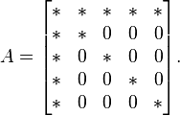

Note: Assign the array in the code. Don’t take from the user or don’t generate randomly.

int[,] a = new int[,] {{4, 7, 8, 9, 2},
{2, 5, 0, 0, 0},
{7, 0, 6, 0, 0},
{2, 0, 0, 4, 0},
{7, 0, 0, 0, 1}};
Output: true

4- Write a C# program that prints the result of the following mathematical formula.

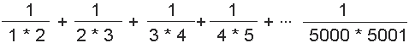

5- Write a program that prints the following output using nested loops.
Don’t use SetCursorPosition command.

0 +
0 ++++
0 +++++++
0 ++++++++++
0 +++++++++++++
0 ++++++++++++++++
0 +++++++++++++++++++
0 ++++++++++++++++++++++
0 +++++++++++++++++++++++++
*************************************
***********************************
*********************************
*******************************
*****************************
***************************
6- Write a program that determines a given matrix is an conference matrix or not.

Conference matrix is a square matrix with 0 on the diagonal and +1 and −1 off the diagonal.

Examples:
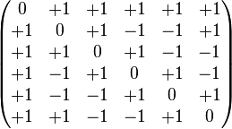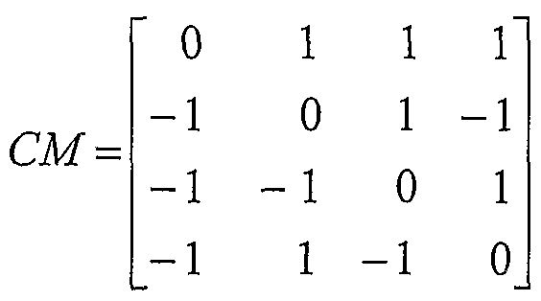

7- Write a program that finds Least Common Multiple (OKEK) of two integers.

Example:
Inputs: 18 45
Output: 90

8- Write a program that prints the following output using nested loops.
Don’t use SetCursorPosition command.

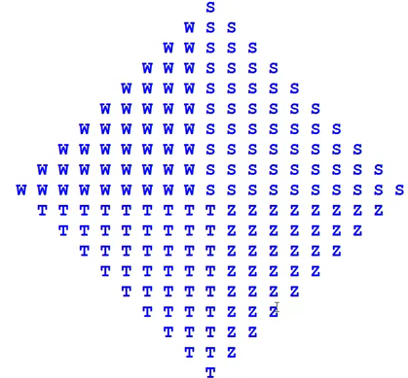

9- Write a program that determines a given matrix is a Redheffer matrix or not.

a Redheffer matrix is a (0,1) matrix whose entries a_{ij} are 1 if i divides j or if j = 0; otherwise, a_{ij} = 0.

Examples:
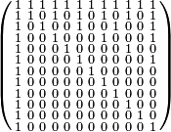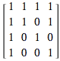

Note: Assign the array in the code. Don’t take from the user or don’t generate randomly.

int[,] a = new int[,] {{1, 1, 1, 1},
{1, 1, 0, 1},
{1, 0, 1, 0},
{1, 0, 0, 1}};
Output: true

10- Write a C# program that takes n numbers from the user and determines that these numbers are Hexagonal numbers or not.

A Hexagonal number is a number that can be represented by a regular geometric arrangement of equally spaced points, and 6-polygonal numbers of the form n(2n-1).

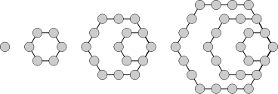

The first few hexagonal numbers are: 1, 6, 15, 28, 45, 66, 91, 120, 153, 190, 231, 276, 325, 378, 435, 496, 561, 630, 703, 780, 861, 946, 1035, 1128, 1225, 1326, ...

Example:
Input: n=6

Input: 1431
Output: true

Input: 2016
Output: true

Input: 1700
Output: false

Input: 1225
Output: true

Input: 100
Output: false

Input: 1653
Output: true

11- Write a program that prints the following shape using nested loops.
Don’t use SetCursorPosition command.

3
5 6
7 8 9
9 10 11 12
11 12 13 14 15
13 14 15 16 17 18
15 16 17 18 19 20 21
17 18 19 20 21 22 23 24
19 20 21 22 23 24 25 26 27
21 22 23 24 25 26 27 28 29 30

12- Write a program that determines a given matrix is a Bidiagonal matrix or not.

A bidiagonal matrix is a matrix with non-zero entries along the main diagonal and either the diagonal above or the diagonal below.

Examples:
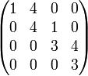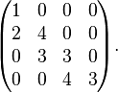

Note: Assign the array in the code. Don’t take from the user or don’t generate randomly.

int[,] a = new int[,] {{1, 4, 0, 0},
{0, 4, 1, 0},
{0, 0, 3, 4},
{0, 0, 0, 3}};
Output: true

int[,] a = new int[,] {{1, 0, 0, 0},
{2, 4, 0, 0},
{0, 3, 3, 0},
{0, 0, 4, 3}};
Output: true
13- Assume that h(t) = 0.12t⁴ + 12t³ - 380t² + 4100t + 220 represents the height of a weather balloon at time t (measured in hours) for the first 45 hours after its launch.

Write a program that creates a table of the height at time t from t = 0 to 45 and finds its maximum height?

14- Write a program that prints a new-year tree by using nested loops.
Don’t use SetCursorPosition command.

x
xxx
xxxxx
xxxxxxx
xxx
xxxxx
xxxxxxx
xxxxxxxxx
xxxxx
xxxxxxx
xxxxxxxxx
xxxxxxxxxxx
xxxxxxx
xxxxxxxxx
xxxxxxxxxxx
xxxxxxxxxxxxx
xxxxxxxxx
xxxxxxxxxxx
xxxxxxxxxxxxx
xxxxxxxxxxxxxxx

15- Write a program that finds a given matrix is a skew-symmetric matrix or not. The program should print true or false.

A skew-symmetric matrix is a square matrix; if the entry in the i ^{th} row and j ^{th} column is a_{ij}, then the symmetric condition becomes a_{ij} = −a_{ji}.
In addition, all elements in diagonal must be zero.

Examples:
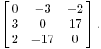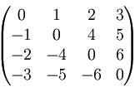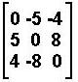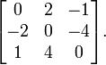

16- 2- Write a program that takes a number (n) from the user and then prints the result of n*5 (n multiplied by 5). Don’t use any addition (+) and muplication (*) operation in your code.
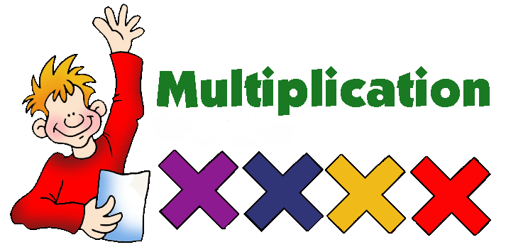
Example: Example: Example:
Input: 8 Input: 12 Input: 20
Output: 40 Output: 60 Output: 100

17-Write a C# program that prints a fish using nested loops as the following:
Don’t use SetCursorPosition command.

************************************ (36 stars)
** ******* ***********
** ***** *********
** *** *******
** * *****
** ***
** * *****
** *** *******
** ***** *********
** ******* ***********
************************************

18- Write a program that takes two numbers x and y from the user and exchanges x^{th} column and y^{th} column of the matrix.

Example:
Input: 2 6

int[,] a = new int [,] {{ 1, 0, 0, 2, 6, -5 },
{ 7, 11, 3, 0, 5, 4 },
{ 0, 0, 8, -6, 4, 9 },
{ 0, 0, 0, 1, 0, 0 },
{ 5, 8, 0, 2, 0, 3 },
{ 0, 1, 28, 3, 2, 0 }};

Output:
1 -5 0 2 6 0
7 4 3 0 5 11
0 9 8 -6 4 0
0 0 0 1 0 0
5 3 0 2 0 8
0 0 28 3 2 1

